Introduction:
Project 1: Cloud and Networking
So far you have studied networking and the concepts of cloud computing. There are 2 case studies given in this project, you are required to go through these case studies and then answer the questions asked under the deliverables section. This project will check your concepts about cloud computing and networking.
CASE STUDY ONE: REAL World CASE STUDY (Why NEED OF CLOUD COMPUTING)
Note: Cross Country it’s a Train service in UK currently they are not using Cloud services they are using their local IT Infrastructure (On-Premises)
Train Service Cross-Country UK Ticket Booking from 9 Am To 2 Pm in UK
• For ticket booking in the UK, for booking of ticket in peak hours is 10 times higher than the rest of the day. The site of https: crosscountry.co.uk /hits by users in 49 transaction/second and GOOGLE hits by users 42000 transaction/second
• Cross country Train service has a locking mechanism that means one seat cannot be allotted to other people, but GOOGLE can share same information to different peoples.
• Then how we manage these transactions, Rail Cross-country provided a temporal solution by barring agent login at peak times, but it is not a good approach.
• Another solution is that adding more thousand servers but buying these servers is very tough for companies which is already in tight budget.
• For some big companies if they buy a thousand servers, but for managing peak hours traffic buying these servers is not the right approach.
• So, there is a need for cloud computing who can manage fluctuations.

Deliverables:
1. What type of cloud services can we use to get rid of this peak hour’s situation and why? it’s your choice you can use any cloud platform because Cloud computing providers, such as Amazon Web Services (AWS), Microsoft Azure, and Google Cloud Platform (GCP), offer this feature. In this point describe the name of this feature, how it works and make a diagram (you can create the diagram in PowerPoint if needed and then upload the diagram in a word document)
There are various cloud services available that can be used depending on the situation. I think the most important cloud service here for this scenario is IAAS, Infrastructure as a service. We can offer and use IAAS to add more servers with a pay as you go service which makes it more affordable. This means that IAAS will help to provide the resources needed and only pay for those resources, no hidden fees. Also, the servers and resources provided by IAAS are high performance, reliable, and fast / high speed. IAAS maintains the servers and resources that the customer needs, on-demand. IAAS cloud provider manages the underlying data center infrastructure for the client, but the customer manages applications, the operating system, and data.
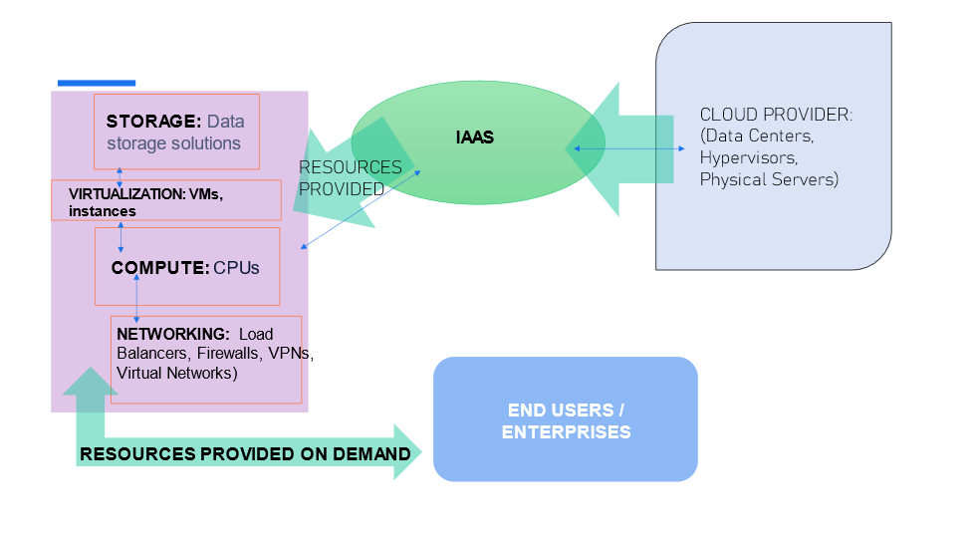

2. We just need these extra server loads for 5 peak hours, so what do you think cloud will be cheap for us instead we buy some more servers to solve this issue. What’s your idea about this and if we choose cloud then why is it beneficial for us?
My idea is that choosing cloud is the better option. Cloud is the most beneficial option for us because of many reasons, but in this scenario a primary reason is due to the cost efficiency. As stated in the scenario bullets above, they are on a tight budget. Cloud computing helps businesses and companies economically, and only charges what is used without any upfront charges or hidden fees. Not only does cloud help with low costs but it also helps with better performance, scalability, and disaster recovery. Also cloud services, such as IAAS, only delivers the resources (extra server loads) that the client needs. The client only pays for what is utilized. Whether the client needs to scale down or in, cloud can make it an easy task without adding any sudden expensive fees.

3. Cloud Computing with Real Life Case Studies and a New Approach of Solving Security, and servers’ availability Issues and Putting Data in Cloud.
Right now, Cross-country Train service uses local on-premises servers and these servers’ availability is 85% because they have 2 datacenters one in London City UK and another is in Manchester city UK, if the London datacenter is down Manchester datacenter gives them backup. Manchester city data center is down then London data center gives them backup. You have more responsibility to manage both data centers 24/7 staff available for facility support, Redundancy and load balancing for High availability.
So, what do you think if we migrate to the cloud, so cloud will give us that kind of Servers / datacenter availability feature or not? if Yes Describe in few words with the help of diagram (you can create the diagram in PowerPoint if needed and then upload the diagram in a word document)
Yes, migrating to the cloud is a better option because on premises data centers have more limitations. For example, on premises servers availability percentage is 85% but the cloud provides enhanced availability, which means there is very little downtime and better continuity. The cloud infrastructure percentage for servers availability is 99.99%. Also, the cloud offers more availability data center zones within each region, which also enhances business/client continuity and reduces failures. Contrary to on-prem services, the cloud provides regions that have many availability zones, so if one availability zone fails it doesn't affect other availability zones that are still active (see diagram below). Allocating resources across availability zones within regions ensures redundancy, high availability, and superior performance. Additionally, in cloud infrastructure, load balancing prevents overloads and enhances scaling. In this scenario, using load balancers ensures that the cross country train service is distributing traffic efficiently during peak hours. Also, the client can choose between AWS, Azure, or google cloud as the cloud provider.
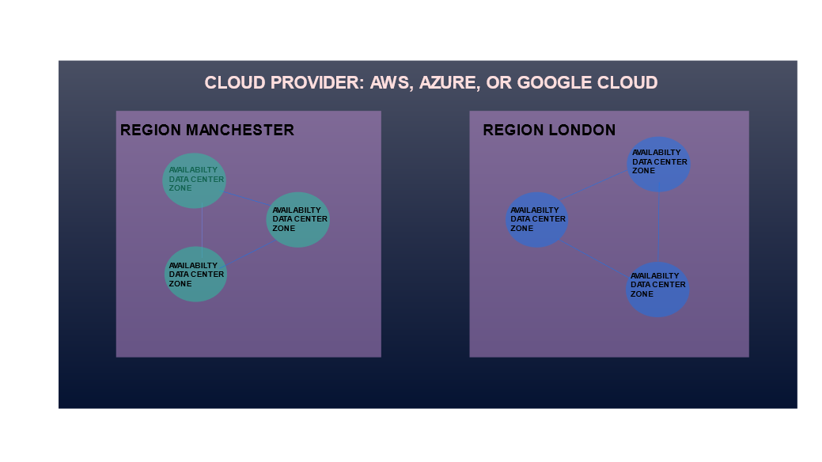

4. Assume that CrossCountry Trains service currently using 500 servers (On-prem)and the company policy and it is necessary to update the servers after 4 years which is cost affecting every 4 years and these servers consume electricity , labors, On-premises datacenter day and night shift staff, high secure environment, disaster recovery measure, now you have to go the cloud(AWS or Azure, Google cloud) what is the best tool you can use for these calculation whether your company should go for cloud or not. This part gives you the estimated cost of cloud with your existing current on-premises environment.( This feature is available in Amazon Web Services (AWS), Microsoft Azure, and Google Cloud Platform GCP use this feature and estimate the cost in Excel file)
Whether the company chooses cloud or not, the best tool to use for this specific situation is the pricing tool found on AWS, Azure, or Google cloud. The pricing tool is beneficial because it estimates the amount that will be paid before any resource is deployed or launched. The pricing tool allows better decision making, due to forecasting/prediction, and cost optimization. I used the AWS pricing tool and I specified the instance amount, according to the data given. The cost was estimated at a monthly cost of $1.46/Month for the train service which is located in the UK, according to the scenario. However, this is only an estimation because it does not include taxes or actual usage of resources. And the client will only pay for what is used.
Submission:
Answer the questions asked under the deliverables section on the word document for this case study and upload the document under the Project Submission section in the dashboard.
CASE STUDY 2: (Cloud and Networking Concepts)
As we know cloud grows and, In the cloud, + we learn about cloud computing, and as we know cloud is a combination of 300 plus technologies and 300 + technologies divided into 3 categories one is SAAS and second is PAAS and IAAS in other words it’s a deployment model of cloud computing of AWS and Azure and other cloud platforms.
Deliverables:
1. Define what is SAAS and how SAAS makes cloud engineers’ life easy?
SAAS stands for Software as a Service. SAAS is hosted by 3rd party companies or vendors who provide applications that are accessed via the internet using a subscription; such as Office 365, Salesforce, and Gmail. SAAS offers many benefits for cloud engineers. For example, lower economical costs, much flexibility and ease in scalability, and artificial intelligence features that are beneficial and user friendly. SAAS does not require the management of the infrastructure. SAAS includes automatic routine maintenance and updates. The security for SAAS is built in. One of the biggest ways in which SAAS makes cloud engineers’ life easy is due to the ease in cost and scalability. Cloud engineers are able to scale out or up when more resources or servers are needed based on business needs, or scale in or down when resources or servers are no longer needed. This is called horizontal and vertical scaling, which is extremely important for cloud engineers, and SAAS makes it easier to execute these provisions due to the subscription based/usage based costs.
2. Create a diagram of SAAS, PAAS and IAAS and define the main difference.
The main differences between SAAS, PAAS, and IAAS are the responsibilities of resources provided that are distributed within the cloud service, regarding users and the cloud administrators. SAAS users do not manage the infrastructure, although the cloud provider does. Whereas, users who use IAAS have the responsibility to manage the infrastructure such as the operating system, but IAAS users do not manage the physical servers underlying infrastructure. PAAS cloud engineers are responsible for creating, building, and launching applications on the platform. PAAS is mainly used by cloud developers. As seen in the diagram below, SAAS offers hosted applications, such as office 365 or salesforce, which are resources accessed via the internet from 3rd party vendors for the users. Cloud engineers can use SAAS for security purposes, performance, storage, and monitoring; SAAS enhances productivity. As seen in the diagram, PAAS is responsible for infrastructure software and operating systems such as oracle or windows. And finally, IAAS cloud administrators have more control over the infrastructure such as the virtualization, servers, networking, and data center.
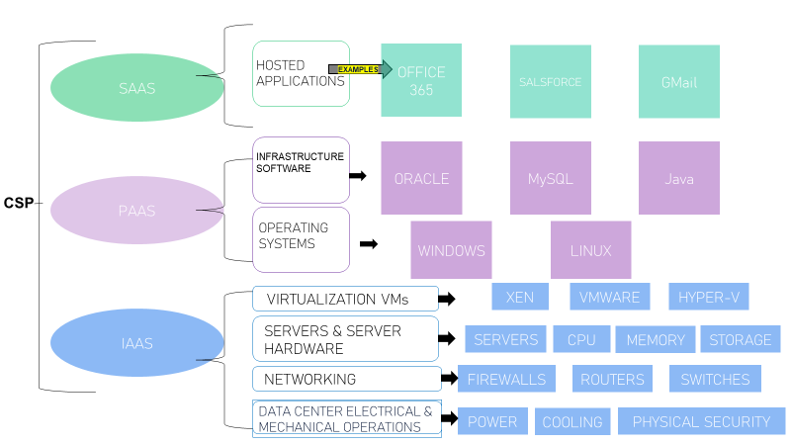
3. In CompTIA Network+ we learn OSI Model and in the public cloud we find a similar concept when talking about the shared responsibility model, where we draw the line of responsibility between the public cloud provider and the customers. Given below Is the diagram of shared responsibility between cloud providers and customers fill the box with who are the responsible.
Example: if we talk about Application layer in IAAS and PAAS it’s a customer responsibility to install and manage the application but in SAAS it’s a Cloud service provider responsibility …Fill all the Boxes.

Layer | Infrastructure as a Service |  | Platform as a  Service |  | Software as a  Service
 | (IAAS) |  | PAAS |  | SAAS
Data | Customer |  | Customer |  | Customer,  Cloud Provider
Application | Customer |  | Customer |  | Customer,  Cloud Provider
Operating  System | Customer |  | Cloud Provider |  | Cloud Provider
Virtualization | Cloud Provider |  | Cloud Provider |  | Cloud Provider
Servers | Cloud Provider |  | Cloud Provider |  | Cloud Provider
Storage | Cloud Provider |  | Cloud Provider |  | Cloud Provider
Network | Cloud Provider |  | Cloud Provider |  | Cloud Provider
Physical | Cloud Provider |  | Cloud Provider |  | Cloud Provider

Submission:
Answer the questions asked under the deliverables section on the word document for this case study and upload the document under the Project Submission section in the dashboard.
Project Grading:
Your project will be graded based on the following criteria.
• The quality and depth of your responses to the case-specific questions.
• The accuracy and clarity of the diagrams you construct as requested in the case.
Important Note:
You are required to upload 2 MS-word documents. 1 document for each case and make sure that you rename the documents as
Project 1 – Case study 1
Project 1 – Case study 2

